* **WEEK 1 – 27 JULY 2023**
* INTRODUCTION TO JS

JavaScript (JS) is a versatile programming language widely used for web development. It empowers interactive and dynamic web content, enabling actions like form validation, animations, and real-time updates without reloading pages.

For example, consider a weather app that uses JS to fetch live data and display it to users, creating a seamless and engaging user experience. JS operates in browsers, making websites more engaging and responsive, enhancing user interaction beyond static pages. Its flexibility and ubiquity make it a cornerstone of modern web development, facilitating engaging online applications across various devices.

* INTRODUCTION TO ES6 – ECMAScript 6

ES6, short for ECMAScript 6 or ES2015, is a major update to the JavaScript language, enhancing its readability, maintainability, and functionality. It introduces modern syntax, arrow functions, classes, template literals, and more. For instance, arrow functions simplify function declarations:

// ES5 function

function multiply(a, b) {

return a * b;

}

// ES6 arrow function

const multiply = (a, b) => a * b;

ES6 empowers developers to write cleaner, more efficient code, leading to improved software development across various domains.Top of Form

* OBJECTS

In JavaScript, objects are a fundamental data type used to store and organize data. They are collections of key-value pairs where keys are strings (or Symbols) that uniquely identify values. Objects can hold various types of data, including other objects, functions, and primitive values like numbers and strings.

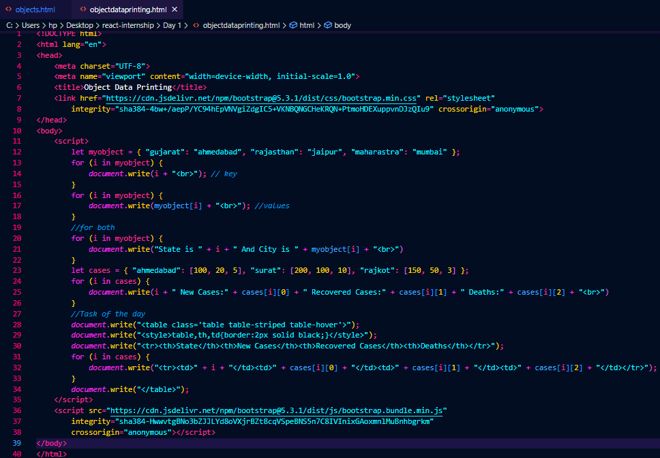

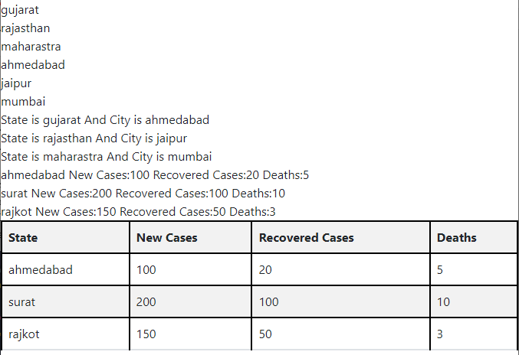

Output:

* **WEEK 1 – 28 JULY 2023**
* JS Functions & Arrow Functions

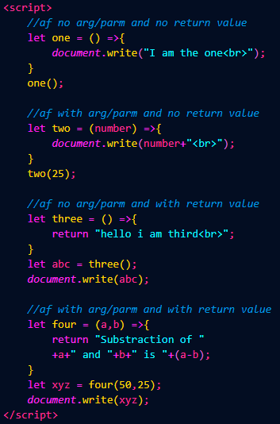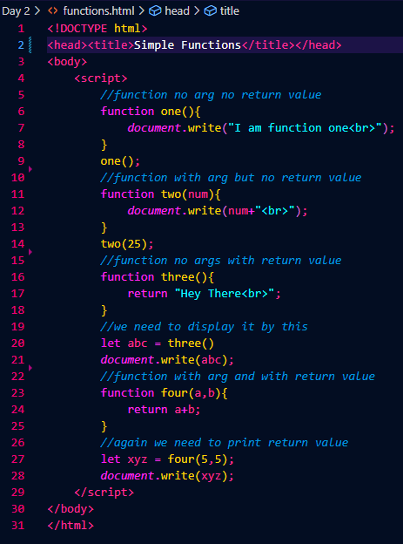

Outputs:

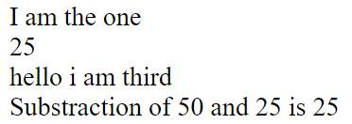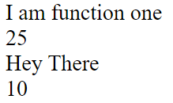

* Async Function

Async/Await is a modern JavaScript feature simplifying asynchronous code. It allows functions to pause execution until an asynchronous operation completes, enhancing code readability. The "async" keyword marks a function as asynchronous, while "await" is used within that function to wait for a Promise to resolve before continuing, reducing callback nesting and improving error handling.

* BitCoin API

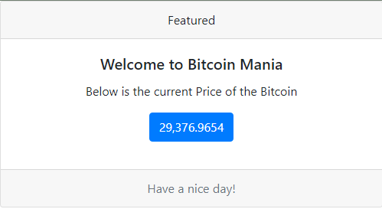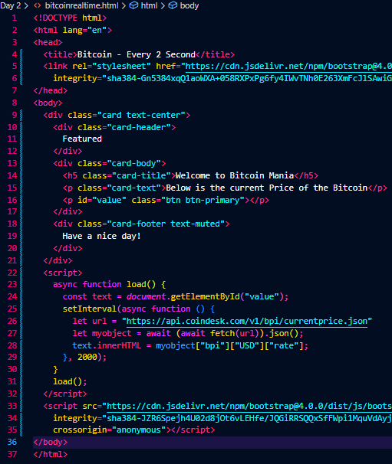

Output:

* **WEEK 1 – 31 JULY 2023**
* 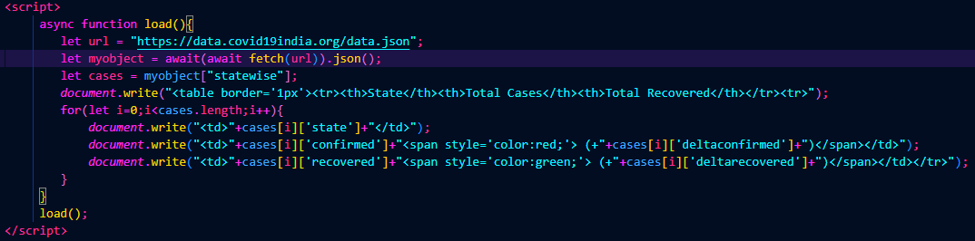Covid API – Data Fetching and mapping

Output:

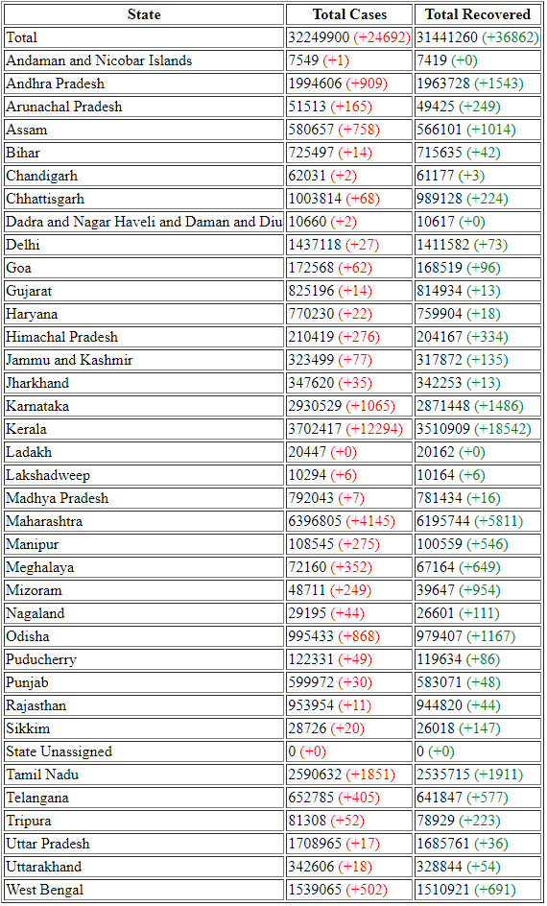

* 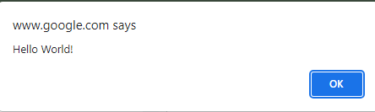USER INPUT 1: JS Pop Up Boxes

Alert: Displays a message to the user.

Example: alert("Hello, world!");

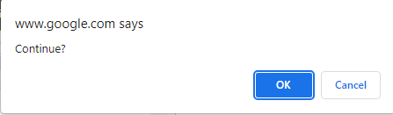

Confirm: Prompts user for yes/no choice.

Example: let choice = confirm("Continue?");

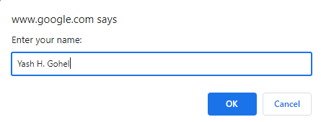Prompt: Accepts user input.

Example: let name = prompt("Enter your name:");

* USER INPUT 2: Form to Variable

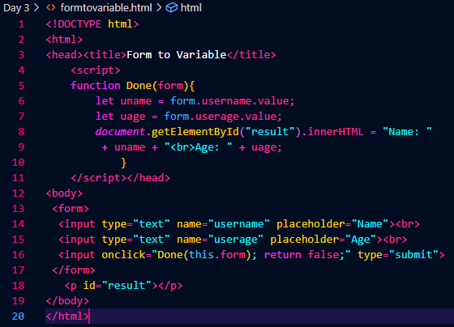

Output:

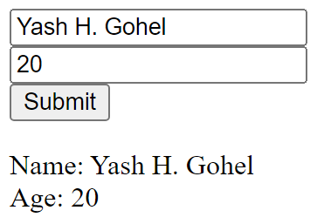

* **WEEK 1 – 1 AUGUST 2023**
* Form to Table

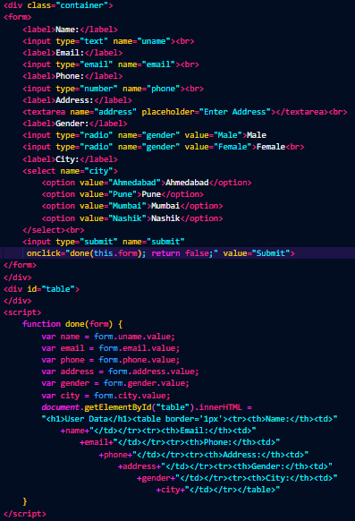

Output:

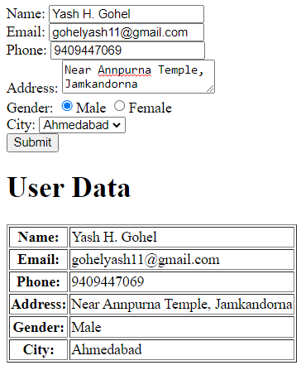

* JS Arrays

JavaScript arrays are ordered collections of data items, allowing storage of multiple values in a single variable. They can hold various data types and have versatile methods for manipulation.

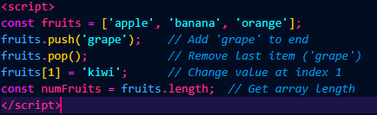

* **WEEK 1 – 2 AUGUST 2023**
* Task Assignment

1. API: https://data.covid19india.org/data.json - Allow user to input date in text box. - On click of submit, It should display number of new cases and deaths occurred on that day. - Check below reference output. - If Field is blank print message : Please enter date instead of table. - If Date not matched: print date not found instead of table.
2. API: https://api.mfapi.in/mf - Print total number of schemes available in this API. - Allow user to input scheme code in text box. - Search scheme code from this API and print scheme name. - If blank print message: Please enter scheme code - If not found print message : Scheme not found

* Covid Data Search

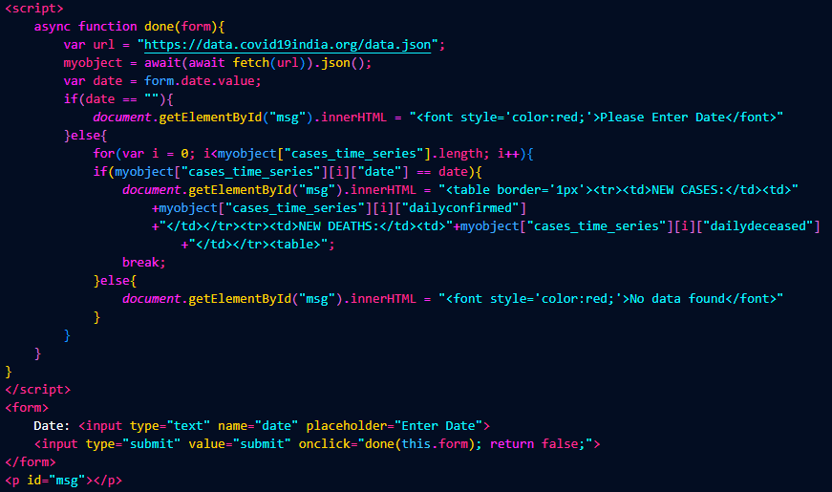

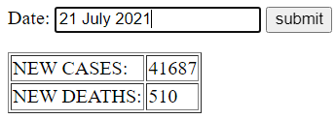Output:

* Mutual Fund API

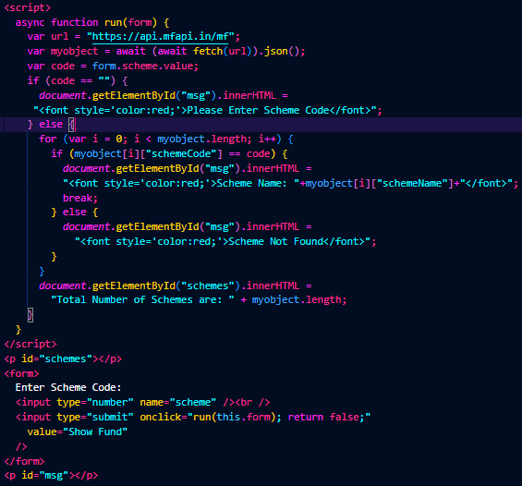

Output:

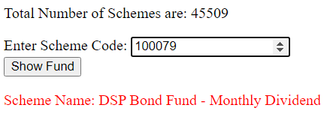

* **WEEK 2 – 03 AUGUST 2023**
* REACT Environment setup (Node JS Installation)
* First React App

Setting up a React environment involves installing Node.js and using Node Package Manager (npm) to manage packages. Follow these steps:

1. **Install Node.js and npm:**

* Download and install Node.js from https://nodejs.org/

After installation, open a terminal or command prompt and verify with:

*node -v*

*npm -v*

1. **Create a React App:**

* Open a terminal and run:

*npx create-react-app learning-demo*

* This creates a new React app named learning-demo.

1. **Navigate to the App Directory:**

* Move to the app directory

*cd learning-demo*

1. **Start the Development Server:**

* Code:

*npm start*

1. **Explore and Edit:**

* Open your code editor and navigate to src directory. Edit src/App.js to modify your app.
* Functional Components
* Class Components

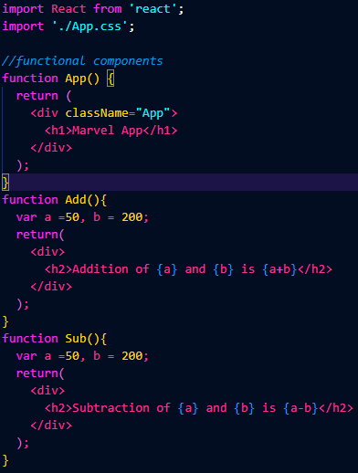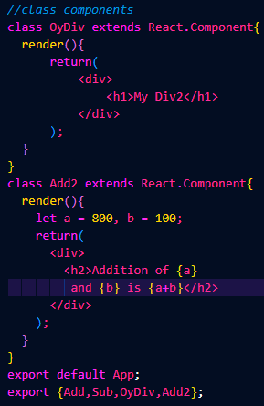

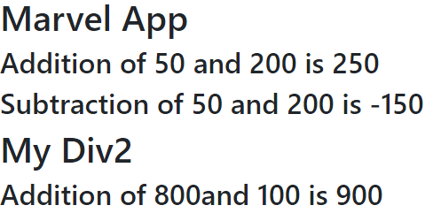Output:

* **WEEK 2 – 04 AUGUST 2023**
* Variable Data Map
* Object Map

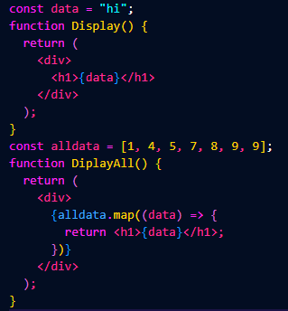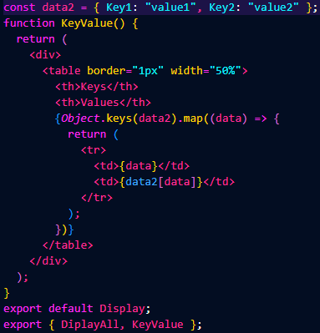

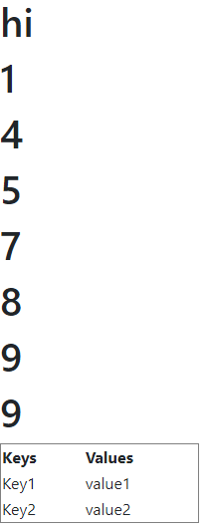

Output:

* **WEEK 2 – 07 AUGUST 2023**
* React Props

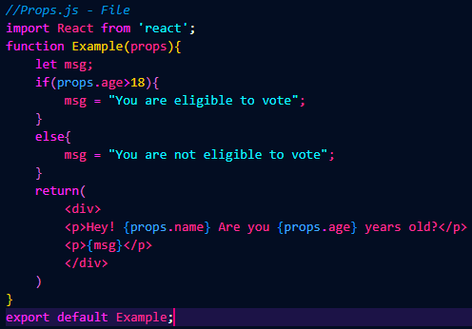

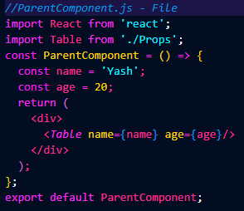

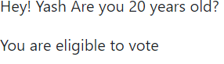Output:

* React Bootstrap

To use React Bootstrap in our Project some steps are given below:

1. **Install React Bootstrap:**

* Open terminal and navigate to app's directory, then install React Bootstrap and its peer dependency, Bootstrap CSS:

*npm install react-bootstrap bootstrap*

1. **Import Bootstrap CSS:**

* In app's entry point (usually src/index.js or src/index.js), import the Bootstrap CSS at the top:

*import 'bootstrap/dist/css/bootstrap.min.css';*

1. **Using it:**

* 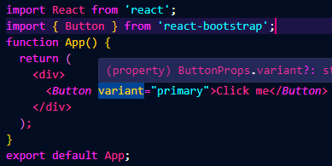Import the components we need and incorporate them into our React components. For example, to use a simple button:

Output:

1. **Start the Development Server:**

* Code:

*npm start*

* **WEEK 2 – 08 AUGUST 2023**
* React Hooks: UseEffect and UseState
* API Data Fetch with React
* **UseEffect:**

In React, useState is a hook that lets our functional components have their own state. It's like a box where we can store and update data that can change over time.

* **UseState:**

useEffect is another hook that lets our components perform actions in response to changes. It's like a sidekick that helps our component respond to things happening, such as data fetching or updating the title of a webpage.

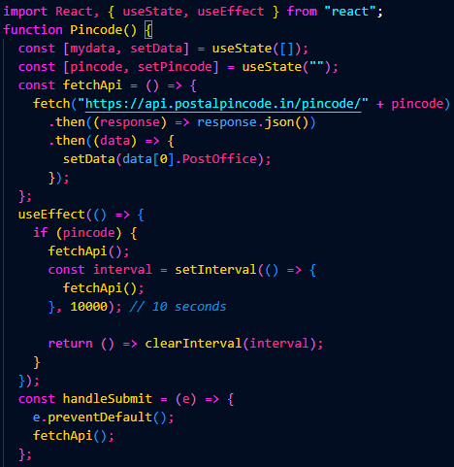

Code:

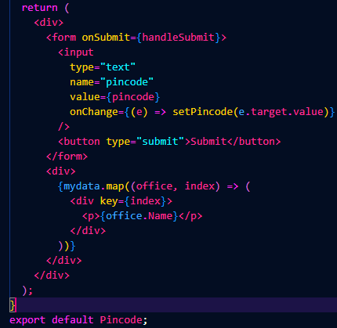

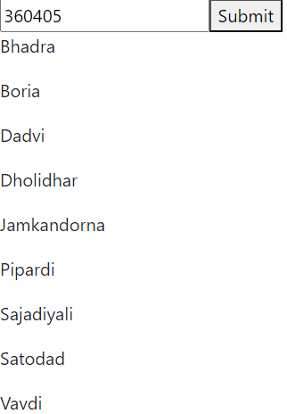

<-: Output

* **WEEK 2 – 09 AUGUST 2023**
* ASSIGNMENT TASK

Develop one web page in react with professional card layouts of react bootstrap. (You can use any code of card from internet. Try to add card with professional look).

* API BASED REAL TIME NEWS WEB APPLICATION – THE PROJECT

Code:

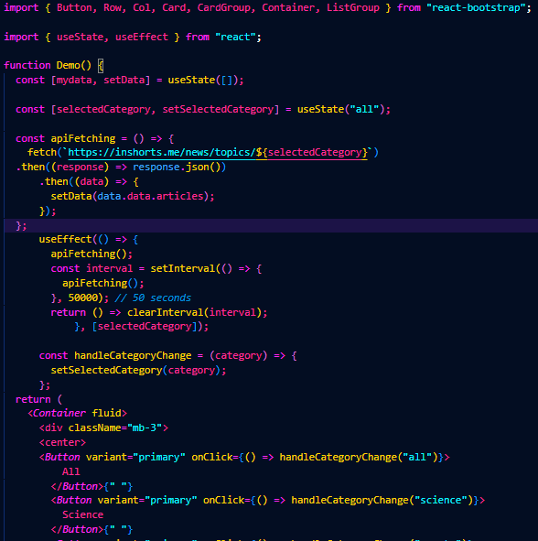

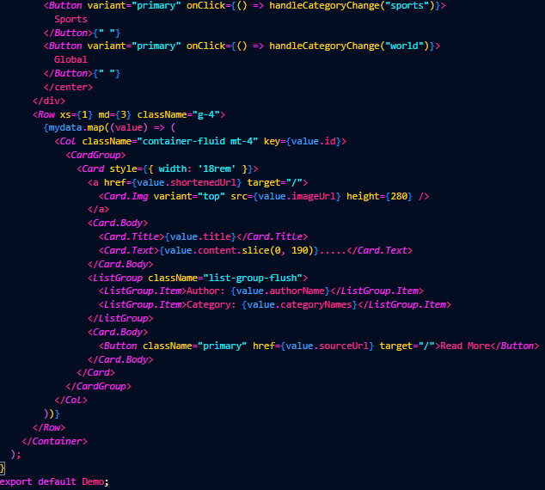

Output:

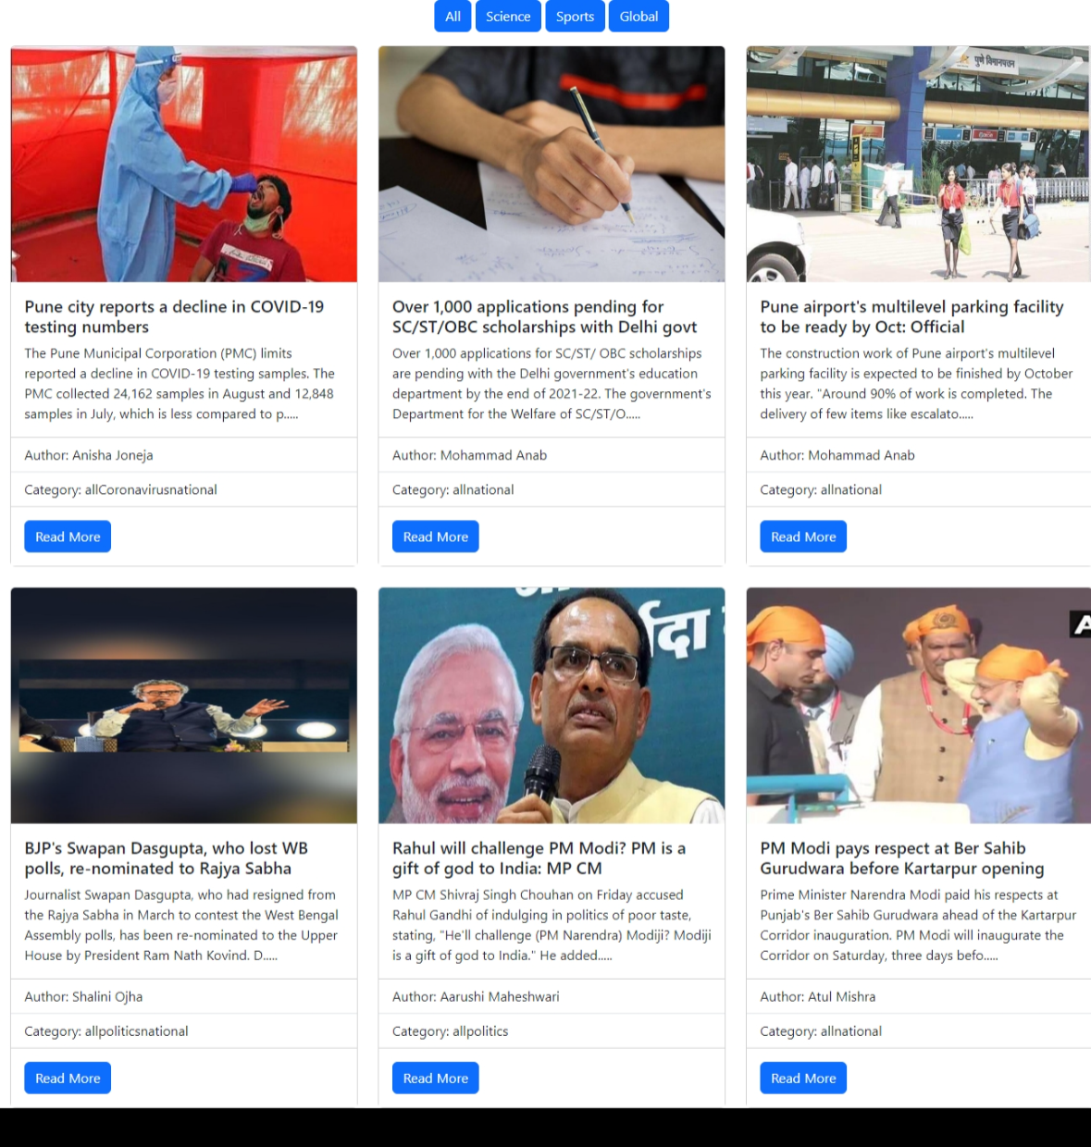

* **WEEK 2 – 10 AUGUST 2023**
* Conclusion

Throughout this React JS internship, I delved into the core concepts of JavaScript, ES6, and React, shaping a solid foundation for modern web development.

I learned to manage state with useState and handle side effects using useEffect. I explored APIs, fetching real-time data, and rendering dynamic content.

By integrating React Bootstrap, I enhanced my UI with elegant components. This journey has equipped me to build interactive, responsive, and feature-rich web applications.

Looking ahead, I'm excited to apply my newfound skills and continue evolving as a proficient React developer.